1. A picture containing background pattern

   Description automatically generated
2. Graphical user interface, application

   Description automatically generated
3. 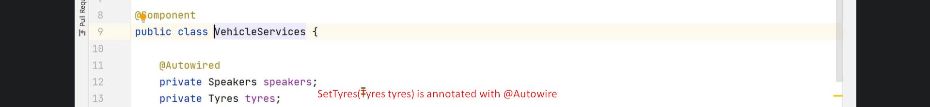
4. 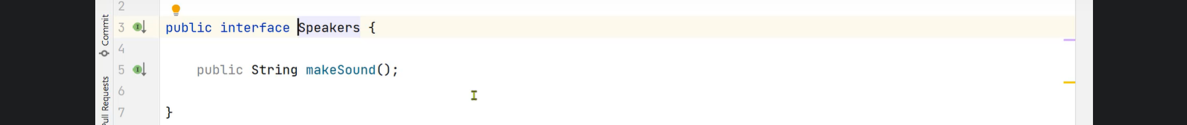
5. 
6. Graphical user interface, text

   Description automatically generated with medium confidence
7. Graphical user interface, application

   Description automatically generated with medium confidence
8. Graphical user interface, application

   Description automatically generated with medium confidence
9. A picture containing scatter chart

   Description automatically generated
10. Graphical user interface, text

    Description automatically generated
11. Graphical user interface, text

    Description automatically generated with medium confidence

|  |  |
| --- | --- |
| Package Scan | Class Scan |
| Adv: 100 of components then just mention package name. |  |
| Dis: If some packages contains so many classes having no stereotype annotation and processing time wastate. |  |

